### **AI based discourse for Banking Industry**

### **Run The Application**

**Run the application**

* Open the anaconda prompt from the start menu.
* Navigate to the folder where your app.py resides.
* Now type the “python app.py” command.
* It will show the local host where your app is running on http://127.0.0.1.5000/
* Copy that localhost URL and open that URL in the browser. It does navigate me to where you can view your web page.

Then it will run on localhost:5000

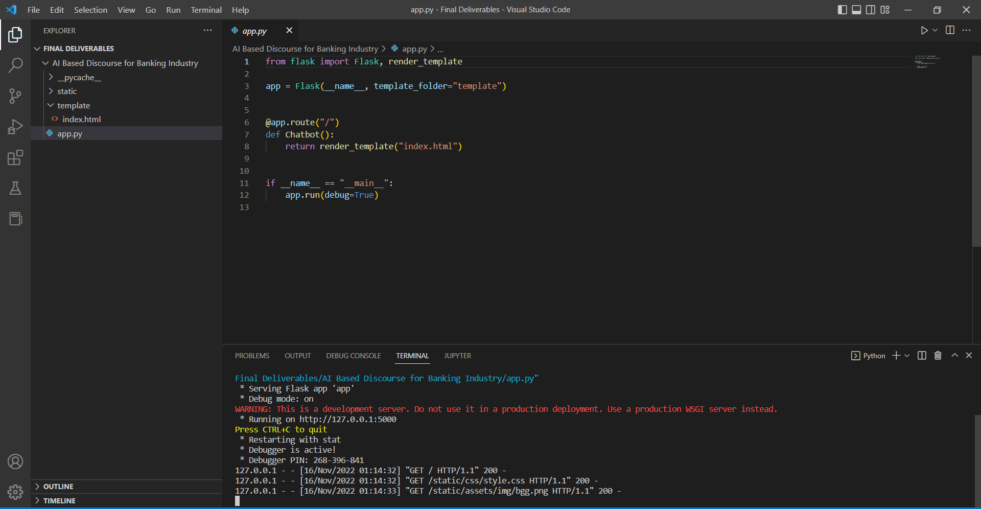

Navigate to the localhost ([http://127.0.0.1:5000/](http://127.0.0.1:8000/)) where you can view your web page.

**FINAL OUTPUT:**



